 |  | How can we bring the histories to life? | What could we include in our planning?  Drawing from Aotearoa New Zealand’s histories in action: Examples in years 9-10
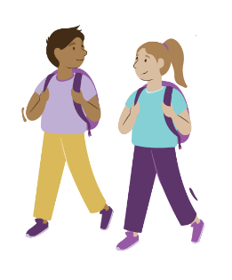 | Ākonga | Make your teaching and learning programme accessible to all ākonga. Increase engagement by making connections to your learners’ lives and whakapapa in your planning. | - Deliver and interpret information using a variety of modes, e.g. texts, in-class experiences.  - Make connections to the identities of ākonga, and who they are as learners in their world.  - Link learning about events in the past to current examples and themes.
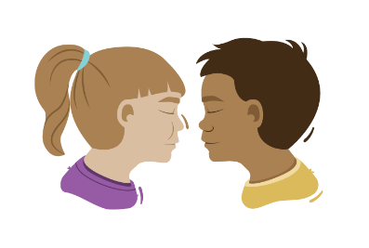 | Whānau and Community | Plan how you will make connections with knowledge from whānau, community, iwi, and hapū. | - Tell stories of local significance and about local people and places.  - Find out what is important to whānau in national and local contexts, and to them personally.  - Consider opportunities for students to share their learning with others, in ways that are meaningful to their community
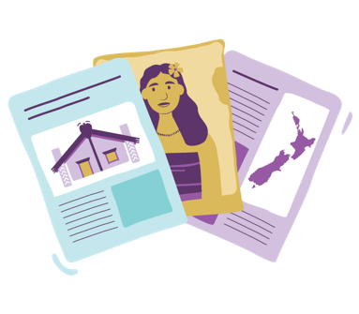 | Resources | Choose resources and experiences that will give learners a range of perspectives and voices reflecting the diversity of Aotearoa. Engage them with stories, experts, and trips to local places. | - Use frameworks to analyse perspectives within resources.  - Look at different texts on the same subject to build rich and layered understandings.  - Deliberately teach the difference between secondary and primary sources.  - Encourage students to actively seek out resources and relevant information that help identify missing voices or stories.
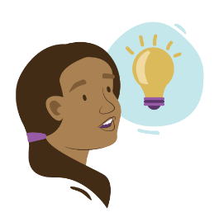 | Understand | Support rich learning for your ākonga by deliberately teaching the big ideas. Explore different ways to connect local history to the big ideas and the wider New Zealand or global context. | - Link national contexts to the big ideas to drive learning.  - Examine ways the big ideas can be seen in contemporary attitudes or events.  - Use the big ideas to give context to consequences and effects for communities and individuals.
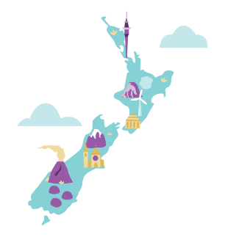 | Know | Check that your theme or topic is significant, relevant, and authentic for mana whenua, whānau and ākonga.  Include explicit support for learners’ histories, languages, cultures, and identities in your planning. | - Link new learning into what students already know and make connections explicit.  - Explore ideas about changes in perspectives over time.  - Check the progress outcomes from the previous phase of learning to see where students have come from and where they can go next.
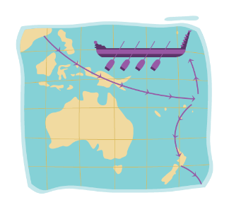 | Do | Develop historical thinking through deliberate teaching of critical thinking strategies. Learners need these many different opportunities to learn and practice so they can apply their learning to new contexts. | - Compare stories about different places, people and objects as a way to deeply explore a theme.  - Deliberately develop critical thinking practices through discussion, questioning, the analysis of texts, and examining social media norms.  - Use a variety of collaborative and interactive ways to interpret the past e.g. debating role playing, mapping  - Explore the past through the physical objects we have to remember, such as memorials and maps.
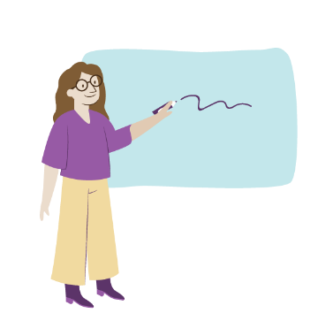 | Teachers | Reflect on the knowledge that you need as a teacher and where you could find it. | - Create an expert focus group with members from whānau and the community.  - Read widely, valuing different perspectives.

