 |  | How can we bring the histories to life? | What could we include in our planning?
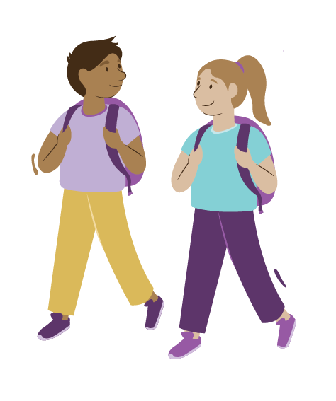 | Ākonga | Make your teaching and learning programme accessible to all ākonga. Increase engagement by making connections to your learners’ lives and whakapapa in your planning.
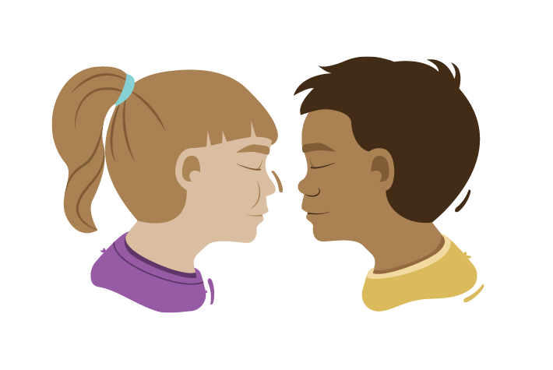 | Whānau and Community | Plan how you will make connections with knowledge from whānau, community, iwi, and hapū.
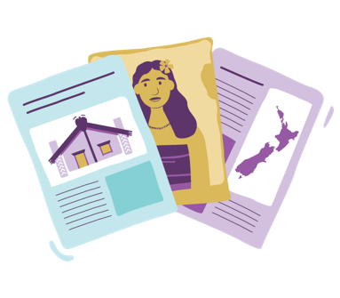 | Resources | Choose resources and experiences that will give learners a range of perspectives and voices reflecting the diversity of Aotearoa. Engage them with stories, experts, and trips to local places.
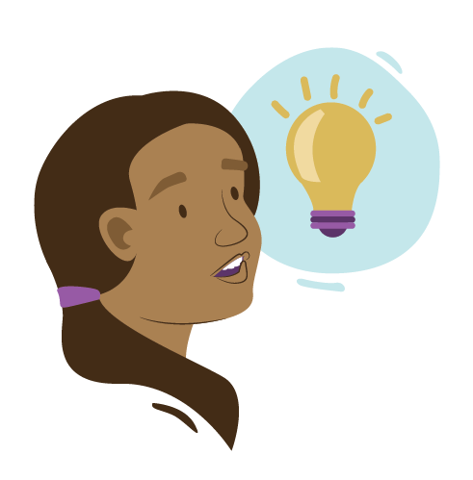 | Understand | Support rich learning for your ākonga by deliberately teaching the big ideas. Explore different ways to connect local history to the big ideas and the wider New Zealand or global context.
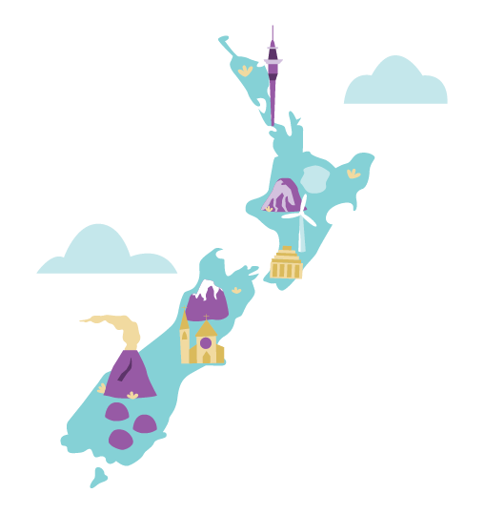 | Know | Check that your theme or topic is significant, relevant, and authentic for mana whenua, whānau and ākonga.  Include explicit support for learners’ histories, languages, cultures, and identities in your planning.
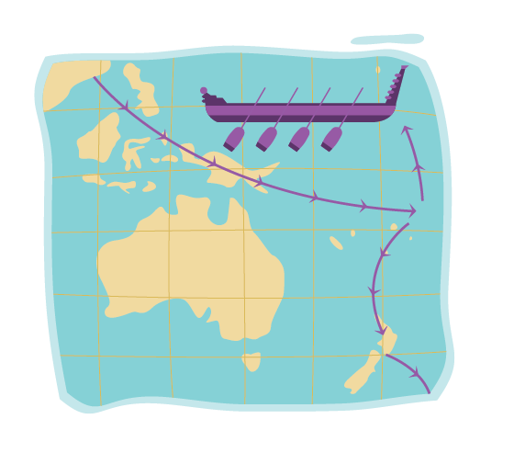 | Do | Develop historical thinking through deliberate teaching of critical thinking strategies. Learners need these many different opportunities to learn and practice so they can apply their learning to new contexts.
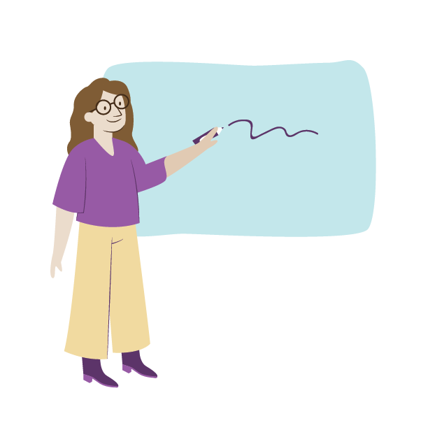 | Teachers | Reflect on the knowledge that you need as a teacher and where you could find it.

